1. **Calculate monthly income of an employee**
   * Steps
     + Identify employee
     + Identify selected employee’s hourly wage
     + Identify employee’s hours worked for the month
     + Multiply wage by hours worked
     + Return total income
   * Flowchart

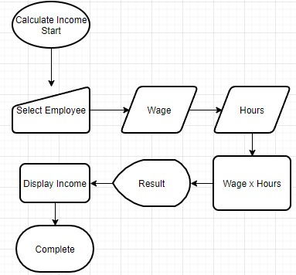

* + Pseudocode
    - START
      * Define variables
        + String name
        + Int wage
        + Int hours
        + Int income
      * Read/Calculate/Print
        + Read name
        + Read Wage
        + Read Name
        + Calculate income: income = wage * hours
        + Print income result
    - END
  + Code

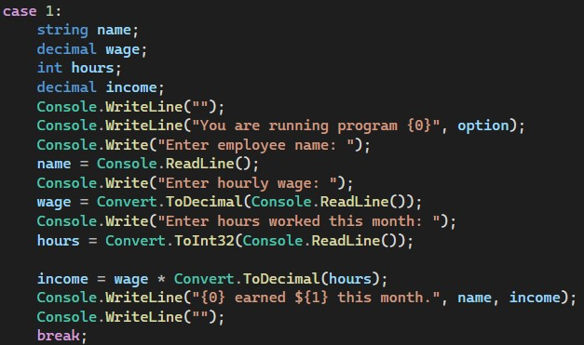

1. **Determine if a student passes or fails a course**
   * Steps
     + Identify student
     + Find student’s grade
     + Set standard passing grade value
     + Compare student’s grade to passing grade
     + Return pass/fail result
   * Flowchart

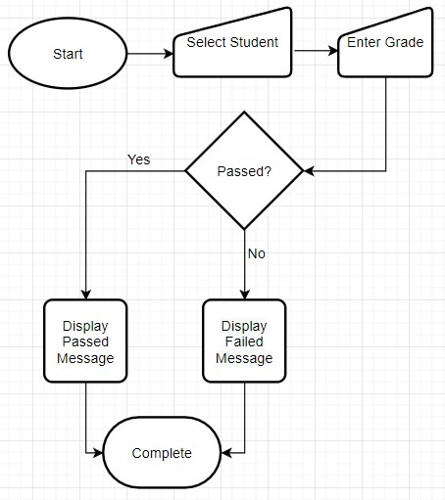

* + Pseudocode
    - START
      * Define variables
        + String studentName
        + Decimal studentGrade
        + Decimal passingGrade
      * Logic
        + Read Name
        + Read Grade
        + If studentGrade >= passingGrade

Print studentName has passed!

* + - * + Else

Print studentName has failed

* + - END
  + Code

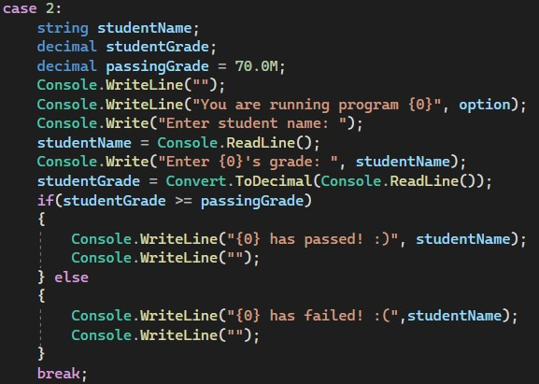

1. **Multiply two values, but if any value is 0, throw message "0”**
   * Steps
     + Enter value 1
     + Enter value 2
     + Check if either value is 0
       - If so, throw message “0”
     + Multiply values
     + Return result
   * Flowchart

* Pseudocode
  + START
    - Define Variables
      * Int val1
      * Int val2
    - Logic
      * If val1 or val2 == 0
        + Print “Value is 0”
      * Else
        + String result = convert.toString(val1 * val2)
        + Print result
  + END
* Code

1. **Division but if second value is 0, throws "you can't divide by 0"**
   * Steps
     + Enter value 1
     + Enter value 2
     + Check if second value is 0
       - If so, throw message “you can’t divide by 0”
     + Divide values
     + Return result
   * Flowchart

* Pseudocode
  + START
    - Variables
      * Int val3
      * Int val4
      * Int divResult
    - Logic
      * Read val3
      * Read val4
      * If val4 == 0
        + Print “You cannot divide by 0.”
      * Else
        + String result = convert.toString(val3 / val4)
        + Print result
  + END
* Code

1. **Compare 2 values and return biggest**
   * Steps
     + Enter value 1
     + Enter value 2
     + Compare values
     + Return biggest value
   * Flowchart

* Pseudocode
  + START
    - Variables
      * Int number1
      * Int number2
    - Logic
      * Read number1
      * Read number2
      * If (number1 > number2)
        + Print number1
      * Else if (number2 > number1)
        + Print number2
      * Else
        + Print number1 (They are same value)
  + END
* Code

1. **Determine if a number is odd or even.**
   * Steps
     + Enter value.
     + Evaluate even or odd
     + Return result.
   * Flowchart

* Pseudocode
  + START
    - Variables
      * Int num
    - Logic
      * Read num
      * If (num % 2 == 0)
        + Write “even”
      * Else
        + Write “odd”
    - END
  + Code

